**Predicting Plant Growth Stages**

**with Environmental and Management Data Using Power BI**

**Dashboard**

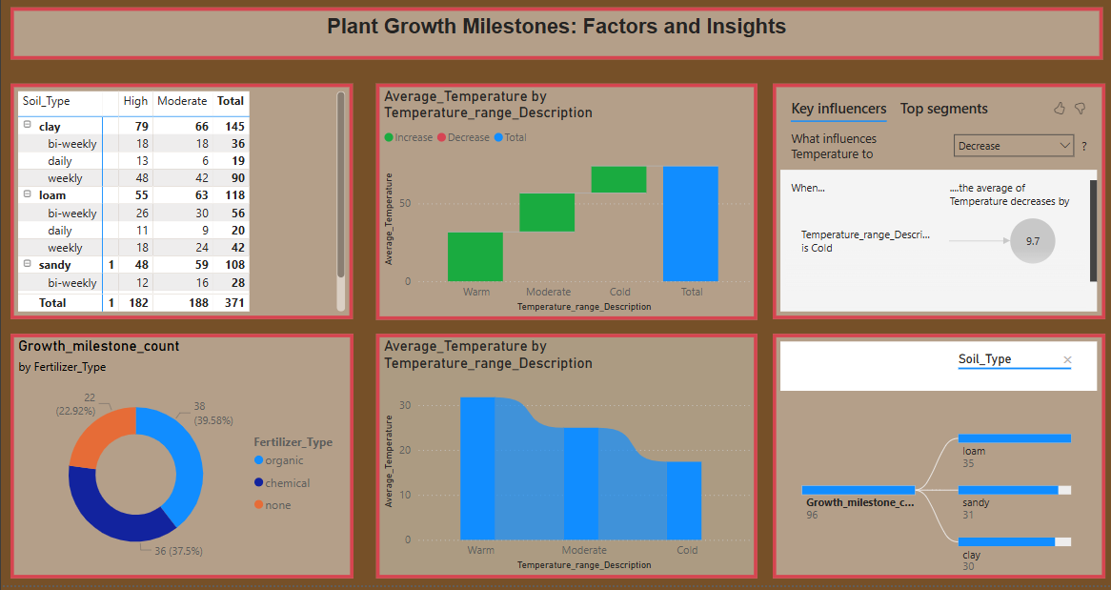

**Report:**

